CANADA
Distributed by Canwest Waste & EnviroTech

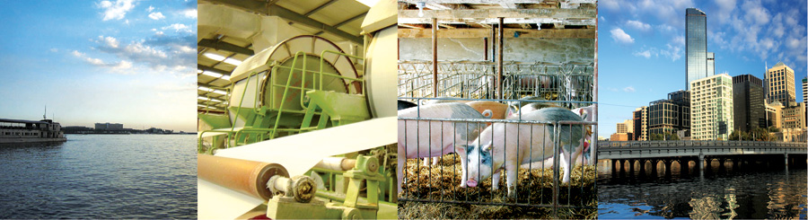
Unlike other water cleaning treatment systems, BioCleaner constantly produces billions of its own good microbes, eliminating the need to add new ones everyday. The microbes are all-natural and have not been genetically modified. They are safe from pathogens or from the risk of mutation. Only microbes classified by the US Center for Disease Control and Prevention (CDC) as BioSafety Level 1 are used in the BioCleaner.

Features:
- Reduces Biological Oxygen Demand (BOD) and COD;
- The BioCleaner continually produces trillions of Microbes that are evenly mixed by the aeration unit;
- Sludge is consumed while maintaining nutrients for recovery later.
- Waste water lagoons become aerobic. Foul odours are virtually eliminated.
- Methane or Hydrogen Sulphide H2S are no longer produced
- Eats sludge fast and uses less than 2.5Hp per unit;
- Waste water becomes completely recyclable. The DO enhanced water with millions of microbes is very beneficial to crop production.
- The Biocleaners can be easily moved to another spot for wider coverage;
- The units are easy to assemble and operate on site;
- Electrical operating costs can be reduced by up to 75% compared with traditional systems.

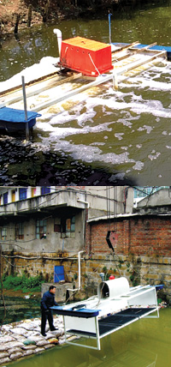
How it works: The machine can break down unwanted waste leaving no sludge at the fastest rate with the lowest carbon footprint. This innovative process has undergone years of critical research and development in the United States and was crafted to even surpass international regulatory standards of treating waste water down to BOD
We can treat water down to recycle grade (irrigation, boiler reuse, cooling towers, washing water) and even to drinking with Reverse Osmosis (RO Membranes). This means that other criteria such as TSS and TDS can also be treated down to Non-Detect (ND) if we design to in such a way.
BioCleaner’s waste water cleaning method is so effective that it produces clear and odorless water, eliminating the need for chlorination that can be harmful to the environment. It also employs different Biosafety Level One microbes to treat different kinds of waste streams. The BioCleaner’s compact form can be easily fitted in existing sewage treatment plants that allows other facilities to benefit from its advantages making it the easiest and most economical solution to all water cleaning needs. The BioCleaner also delivers a very efficient amount of oxygen to the water, transferring 3.6 Kgs of oxygen per hour, enabling the microbes to have a good source of oxygen.

